**ANALYSIS DOCUMENT**

**1. ANALYSYS STUDY:**

Systems analysis the process of observing systems for troubleshooting or development purposes. It is applied to information technology, where computer-based systems require defined analysis according to their makeup and design.

An E-Learning Management System is almost a necessity in day to day services and also due to covid .if all parts of operations are consolidated within one software system so that:

* Manual Learning System not needed
* Communication between Students and their Teacher is facilitated through an integrated database
* Functionality is improved
* Control is facilitated
* Security is enhanced
* Contactless Learning

Analysis study is presented in the form of Software Requirement Specification. Review of SRS is conducted to determine the suitability and the adequacy of the software requirement. The review addresses the following questions/issues:

* Are the requirements appropriate to the user needs or project objectives?
* Are the requirements complete?
* Are the requirements defined unambiguously?
* Are the requirements self-consistent?
* Is every requirement testable?

**2. USER REQUIREMENTS:**

One must know what the problem is before it can be solved. General approaches for determining user requirements are:

* Preliminary investigation – asking general questions
* Analysis of existing System – getting information from existing System

**2.1. PRELIMINARY INVESTIGATION:**

For this, the need arises to understand the viewpoint of two important entities:

* Top management
* Users

In order to gather pertinent information, I interviewed the Top Management (Students and Teachers) and asked the following questions:

* How the present Education System works and what are its drawbacks?
* What is their vision about the new System and what new facilities they want from the new System?
* How will data flow in the System?
* Who will be authenticated to access data and his/her access rights?
* Will users be accustomed to the new system?

To find more about present System’s working mechanism such as the ways of getting inputs and providing outputs, I interviewed the Current Users of the System or Teachers by asking following question:

* Are they comfortable with the present System and flaws exist in it?
* Do they feel the necessity of new System?
* What will be their requirements from new System?
* Are they satisfied with their services in present System?
* Will they be comfortable to use the new System?

After carrying out these interviews, I drew conclusion about the Top Management’s requirements and Users are in support of the new System.

**2.2. ANALYSIS OF THE EXSISTING SYSTEM:**

The existing version of the software was created in JSP, Servlet and MySQL.

This version will also have the same software and hardware specification as the existing one but certain new features will be introduced such as:

* Student Management
* Teacher management
* Course Management
* Manage Employees, Students, Courses etc

**2.3. SYSTEM REQUIREMENT:**

The techniques which were used to collect data in order to determine the System requirements:

* Reviewing organization documents
* Onsite observations
* Conducting interviews

**2.3.1. REVIEWING ORGANIZATION DOCUMENTS:**

I first learnt about how the Schools and Coaching Centers involved in the project. I then, got to know how the department works and the User were directly involved with the application. Teacher records and Student records and the documentation of their system helped me to understand the working of the system.

**2.3.2. ONSITE OBSERVATIONS:**

It is a process of recognizing and observing people, objects and their occurrence to obtain the information. The major objective of the Onsite Observation is to get as close as possible to real System being studied.

Here, I observed the activities of the System directly. I saw the office environment, workload on the System and on the users. The physical layout of the current System along with the location and movement of staff was analysed. In this way, the information about the present workflow, objects and people was gathered.

This helped me to understand various procedures & processes, which were to be developed in the new System.

**2.3.3. CONDUCTING INTERVIEWES:**

Written documents and onsite observation just tell that how the System should operate. They do not include enough details to allow a decision to be made about the merits of System proposal and do not present the user views about the current system.

I conducted interviews of the staff, which were directly involved with the application. Also the regular users of the application were interviewed. Based on their viewpoints, crystal clear System requirements were jolted down.

**2.4. HARDWARE REQUIREMENTS:**

**Processor :** Intel or AMD processor with min. 2GHz

**Ram :** 1GB or more

**Cache :** 512 KB

**Hard disk :** 50 GB hard disk recommended

**External Devices :** Monitor, Keyboard, mouse

**SOFTWARE REQUIREMENTS:**

**Operating System :** Windows 7, 8, 10

**Front End :** JSP

**Back End :** MySQL

**Markup Languages :** HTML

**Other Technologies :** CSS, JQuery, Ajax, JavaScript, Bootstrap, Servlet

**3. FEASIBILITY STUDY:**

Feasibility Study is the test of the System proposal according to its workability, impact on the current System, ability to meet the needs of the current users and effective use of the resources.

Its main objective is not to solve the problem, but to acquire its scope. It focuses on following:

* Meet user requirements
* Best utilization of available resources
* Develop a cost effective System
* Develop a technically feasible System

**There are three aspects in the feasibility study:**

* Technical Feasibility
* Economical Feasibility
* Operational Feasibility

**3.1. TECHNICAL FEASIBILITY**

Issues to be studied are, whether the work for the project will be done with current equipment, existing S/W technology and available personnel? If the new technology is required, then what is the likelihood that it can be developed?

This software is technically feasible. The primary technical requirement includes the availability of Windows 7 or higher version of operating Systems installed in the network. MySQL is also required which was already installed. To develop programs NetBeans 8.1 or higher was required which was also available. Reliability, access power and data security was also available. Thus, through all the ends technical feasibility was met.

**3.2. ECONOMICAL FEASIBILITY**

Issues to be studied are, whether the new System is cost effective or not? The benefits in the form of reduced cost?

This software is economically feasible. As the hardware was installed from quite beginning, the cost on project of hardware is low. Similarly, the software loaded for this project was used for many other applications. The software cost was under budget. As student trainees were developing the application, there were no major personnel costs associated. Moreover, the technical requirements were already available so there was no further expenditure for buying software packages.

**3.3. OPERATIONAL FEASIBILITY**

Issues to be studied are, is there sufficient support for management and users? Is the current method acceptable to users? Will the proposed system cause any harm?

This software is operationally feasible. This application provides the necessary information to the user such as how to enter the information regarding different operations performed on the database. The application was planned in such a way that no prior knowledge was required to go through the various operations. The user just needed to have the basic knowledge of computers.

**4. SOFTWARE REQUIREMENT SPECIFICATION:**

Among all the documents produced during a software development life cycle, writing the SRS document is probably the toughest. One reason behind this difficulty is that the SRS document is expected to cater to the needs of a wide variety of audience. Different people need the SRS document for very different purposes.

Characteristics of a Good SRS Document

Some of the identified desirable qualities of the SRS documents are following:-

**Concise:** The SRS document should be concise and at the same time unambiguous.

**Structured:** The SRS document should be well structured.

**Black-box view:** It should only specify what the System should do and refrain from stating how to do.

**Conceptual integrity:** The SRS document should exhibit conceptual integrity so that the reader can easily understand the contents.

**Response to undesired events:** The document should characterize acceptable responses to undesired events.

**Verifiable:** All requirements of the System as documented in SRS document should be verifiable. This means that it should be possible to determine whether or not requirements have been met in an implementation.

The SRS of E-Learning Management System is as follows:

**4.1. INTRODUCTION:**

**4.1.1. PURPOSE:**

The purpose of this document is to present a detailed description of the E-Learning Management System. It will explain the purpose and features of the system, the interfaces of the system, what the system will do, the constraints under which it must operate and how the system will react to external stimuli. This document is intended for both the Teachers and the developers of the system and will be liable for the approval or disapproval of the project by the community of the Teachers.

**4.1.2. SCOPE:**

An E-Learning Management system will be applicable everywhere, where education exists. It will be more efficient and easier way to have a record on systems through which everyone can easily access it according to his rights as compared to the traditional Learning system. Every institution will prefer the E-Learning Mnagement system instead of the traditional Education system as it contains many useful features and fastest methods for the education.

**4.1.3. DEFINITIONS AND ABBREVIATIONS:**

|  |  |
| --- | --- |
| Following are the definitions for the jargoned words.  **TERMS** | **DEFINITIONS** |
| MySQL | Structure query language for the database purposes. Used to define procedures to store and retrieve data. |
|  |  |
| Database | Collection of all the information monitored by this system. |
| JSP | JSP Hypertext Pre-processor, A server side scripting language, is used to connect the html with the databases. |

**4.1.4. REFERENCES:**

This web application has been prepared on the basis of discussion with Team members, faculty members and also taken information from following books & website.

**Websites:**

➢ www.google.co.in

➢ www.wikipedia.org

➢ www.youtube.com

**Books:**

➢ Fundamental of Software Engineering by Rajiv Mall.

➢ Software Engineering: A practitioner’s approach Ed. by Pressman, Roger.

➢ Software Engineering Seventh Edition Ian Somerville.

➢ Software Engineering Ed.2 by Jalota & Pankaj.

➢ Schaum’s Series, “Software Engineering”.

**4.2. GENERAL DESCRIPTION:**

**4.2.1. PRODUCT PERSPECTIVE:**

In traditional system, Students should have to go the School physically for the Knowledge or some other task. It wastes time.

After implementing the E-Learning Mnagement System Users will be able to connect to his account through the internet connection. Time usage will be minimized, task will be done fast instead of waiting someone other to complete his task.

**4.2.2. FUNCTIONALITIES:**

**a) Online Learning of Concepts:**

Customer will be able Read online while sitting at home by accessing the database of or site using his/her password and account no. allotted him during registration.

**b) Manage the Students :**

It will be easy for the manage the Students. It will provide him/her the opportunity to manage Students.

**c) Manage the Teachers :**

It will be easy for the manage the Teachers. It will provide him/her the opportunity to manage Teachers.

**d) Online record Entry:**

Users will input and maintain their record online. It will be easy and efficient for them to serve more and more people in less time.

**e) Online record search:**

Users will easily search a record and update it if needed. Learning will be faster even physically from the center because it will be very easy for the Students to check the detail of a specific person and update its record if necessary.

**4.2.3. USER CHARACTERISTICS:**

There are various kinds of users for the Courses. Usually web Courses are Learned by various users for different reasons.

The users include:

a) Admin who will be acting as the controller and he will have all the privileges of administrator.

b) Teacher who will handle the operations of the Teacher of that particular batch.

c) Student who will handle the request’s and queries to Teachers and Learn online.

**4.2.4. GENERAL CONSTRAINTS:**

Some general constraints should be defined which will have a great part in the overall succession of the E-Learning project.

**a) HARDWARE REQUIREMENTS:**

As this system is an online Web-based application so a client server will be the most suitable Organizational style for this system. Computer systems will be needed by each of the actor as well as that user must be connected to the internet. So, concisely following hardware will be needed.

1) Computer systems

2) Internet availability

**b) SAFETY AND SECURITY:**

This Project must be safe and secure because users will directly contact their account through the internet. Software will have to identify the valid customer according to his/her bank details and password. So it is a difficult task to prevent the system by major disasters by preventing the unauthorized access to the system.

**4.2.5. ASSUMPTIONS AND DEPENDECIES:**

Following are the assumptions and dependencies which are related to this online banking project.

➢ This project is a stand-alone project so it will not affect the system where it will be embedded.

➢ This project is a web-based project while the staff was addict of using traditional methods of data storage and retrieval so they will be trained a bit to jump to it.

➢ This system will not depend on any other module. It will be a web-based so everyone will independently contact it.

➢ It is will not affect the environment at all.

➢ Educational Institutions will feel free to adopt it because it will not be so much expensive.

➢ As this project contains valuable and new features so it will probably remove the previous online Learning systems embedded in some Schools.

**4.3. SPECIFIC REQUIREMENTS:**

How the E-Learning website will interact with the environment, what will be the functional and non-functional requirement. These all the steps should be defined here for providing a powerful base to the design phase. The design of the project will completely depend on the functional and non-functional requirements. So these should be defined clearly and accurately for the effectiveness.

**4.3.1. FUNCTIONAL REQUIREMENTS:**

Following are the services which this system will provide. These are the facilities and functions required by the customer.

i. Online Learning.

ii. Online books shopping opportunity.

iii. Online data entry by the staff.

iv. Updating the data.

**4.3.2. EXTERNAL INTERFACE REQUIREMENTS:**

These requirements are discussed under the following categorization:

**4.3.2.1. USER INTERFACE:**

Application will be accessed through a Browser Interface. The interface would be viewed best using 1024 x 768 and 800 x 600 pixels resolution setting. The software would be fully compatible with Microsoft Internet Explorer for version 6 and above.

No user would be able to access any part of the application without logging on to the system.

**4.3.2.2. HARDWARE INTERFACE:**

**a) SERVER SIDE:**

* **Operating System:** Windows 7 or higher.
* **Processor:** Pentium 3.0 GHz or higher.
* **RAM:** 256 Mb or more.
* **Hard Drive:** 10 GB or more.

**b) CLIENT SIDE:**

* **Operating System:** Windows 7 or above, MAC or UNIX.
* **Processor:** Pentium III or 2.0 GHz or higher.
* **RAM:** 256 Mb or more.

**4.3.2.3. SOFTWARE INTERFACE:**

**a) CLIENT SIDE:**

HTML, JavaScript, Web Browser, Flash Player, MS Office,

Windows XP or higher.

**b) WEB SERVER:**

HTML, MS Office, Windows XP or above.

**4.3.2.4. COMMUNICATION INTERFACE:**

The Customer must connect to the Internet to access the Website:

* Dialup Modem of 52 kbps.
* Broadband Internet.
* Dialup or Broadband Connection with an Internet Provider.

**4.3.3. NON-FUNCTIONAL REQUIREMENTS:**

Those requirements which are not the functionalities of a system but are the characteristics of a system are called the non-functionalities. Every software system has some non-functionalities. Just fulfilling the requirements of the user is not a good task, keeping the system accurate, easy to maintain, reliable and secure is also a basic part of software engineering. Our site must have the following non-functional requirements so that I could be said as a complete system.

**a) PERFORMANCE CONSTRAINTS:**

This system must be fit according to the performance wise. It should use less memory and will be easily accessible by the user. Memory management should be done wisely so that none of the memory part goes wasted.

**b) HARDWARE LIMITATIONS:**

It should be designed in such a way that cheap hardware must be installed to access and use it effectively. It should be platform independent. There should be no hardware limitations. In should be designed to work with the low specification hardware so that it could easily work with the high specification hardware.

**c) MAINTAINABLE:**

Each of the modules should be designed in such a way that a new module can easily be integrated with it.

**d) RELIABLE:**

It should be consistent in it performance and provide secure transactions.

**e) TESTABLE:**

Each module should be made in such a way to make it easy for all kinds of testing and debugging.

**5. DATA FLOW DIAGRAMS (DFD):**

Data Flow Diagramming is a means of representing a System at any level of detail with a graphic network of symbols showing data flows, data stores, data processes, and data sources/destinations.

The purpose of data flow diagrams is to provide a semantic bridge between users and System developers.

The diagrams are:

* Graphical, eliminating thousands of words;
* Logical representations, modelling ‘WHAT’ a System does, rather than physical models showing ‘HOW’ it does it;
* Hierarchical, showing System s at any level of detail; and Jargon less, allowing user understanding and reviewing.

The goal of data flow diagramming is to have a commonly understood model of a System. The diagrams are the basis of structured System’s analysis. Data flow diagrams are supported by other techniques of structured System s analysis such as data structure diagrams, data dictionaries, and procedure-representing techniques such as decision tables, decision trees, and structured English.

The objective of Data flow diagrams is avoiding the cost of user/developer misunderstanding of a System, resulting in a need to redo System’s or in not using the System.

Having to start documentation from scratch when the physical System changes since the logical System, ‘WHAT’ gets done, often remains the same when technology changes.

It helps in removing inefficiencies of System because a System gets "computerized" before it gets "Systematized". Also helps enabling to evaluate System project boundaries or degree of automation, resulting in a project of inappropriate scope.

## DFD SYMBOLS

1. A SQUARE defines a source or destination of system data
2. An ARROW identifies data flow or data in motion. It is a pipeline through which information flow.

3.A CIRCLE or a BUBBLE (Some people use an over bubble) represents a process transforms in coming data flow into outgoing data flow.

4.An OPEN RECTANGLE is a data store or data at rest or a temporary rest repository of data.

Note that a DFD describe what data flow (logical) rather than they are processed, so it does not depend on hardware, software and data structure or file organization.

**Contextual Diagram :**

STUDENT

Get Result

Add/Delete Course

E-LEARNING

MANAGEMENT

SYSTEM

FACULTY

ADMIN

Add/Delete Instructor

Manage Student/Tutor

Registration

Register

Add Forum

Check Grades

Take Course, Exam

And Submit

Assignments

View Students

Get Results

Gives Tests,

Assignments and Exams

Upload Course Material

**: - Zero Level DFD (CONTEXTUAL DIAGRAM)**

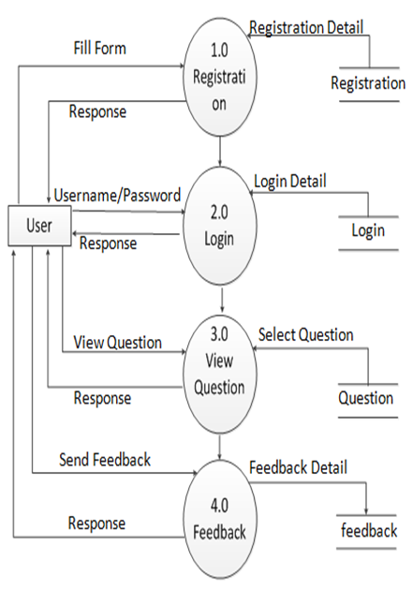

**: - FIRST LEVEL DFD FOR USER**

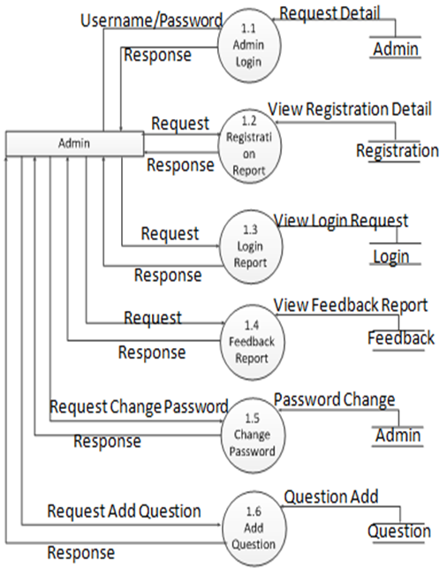

**: - FIRST LEVEL DFD FOR ADMIN**

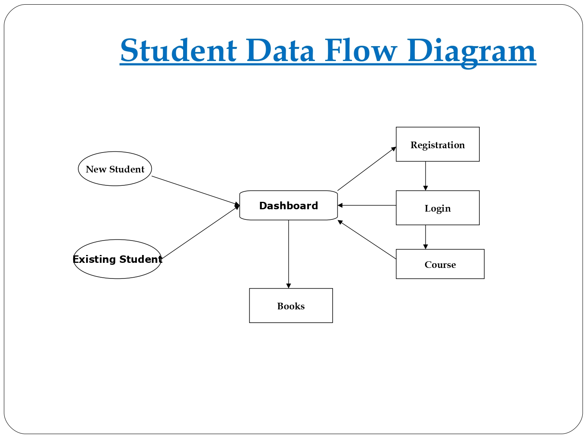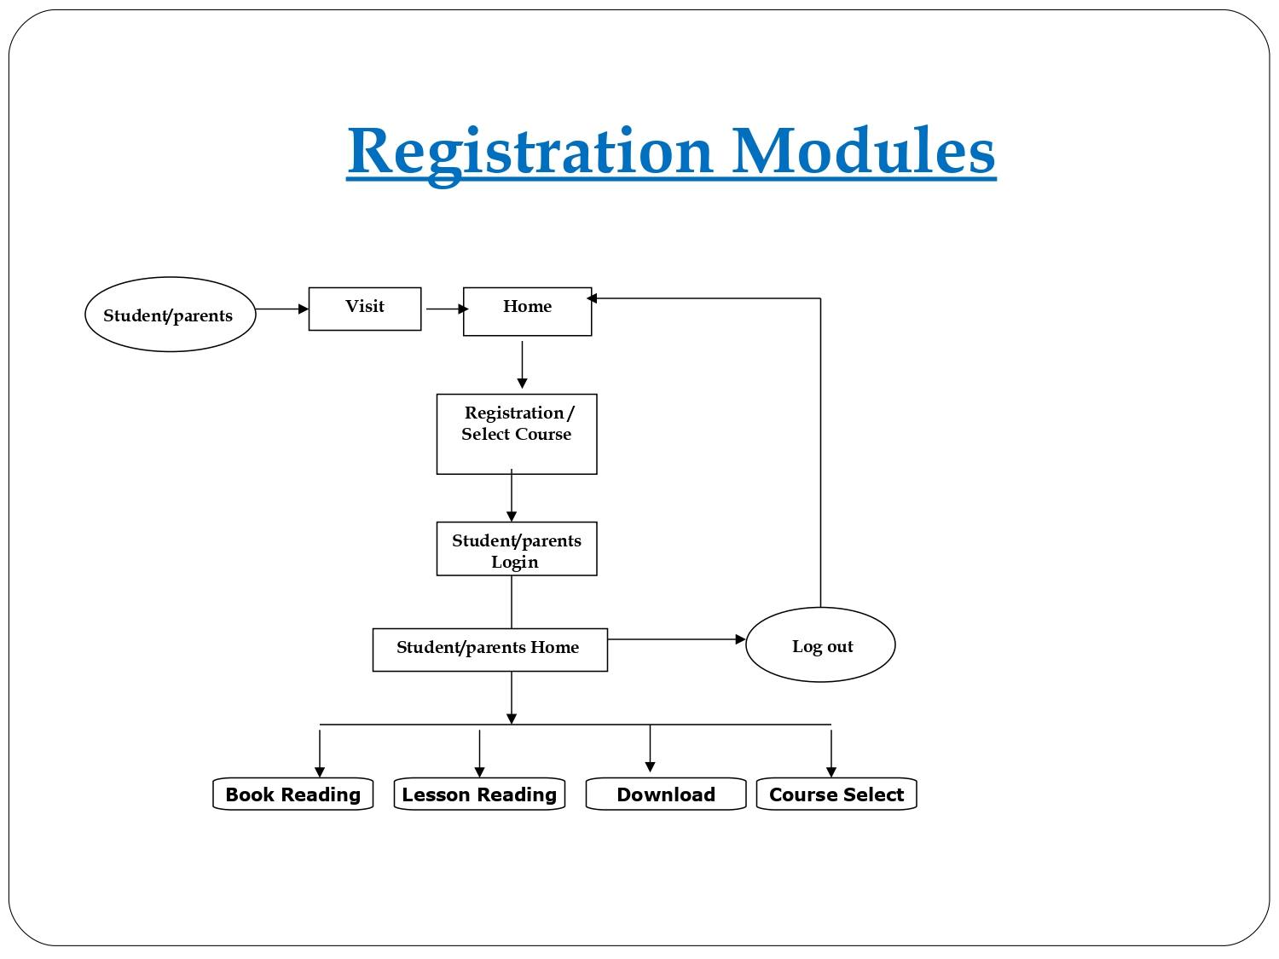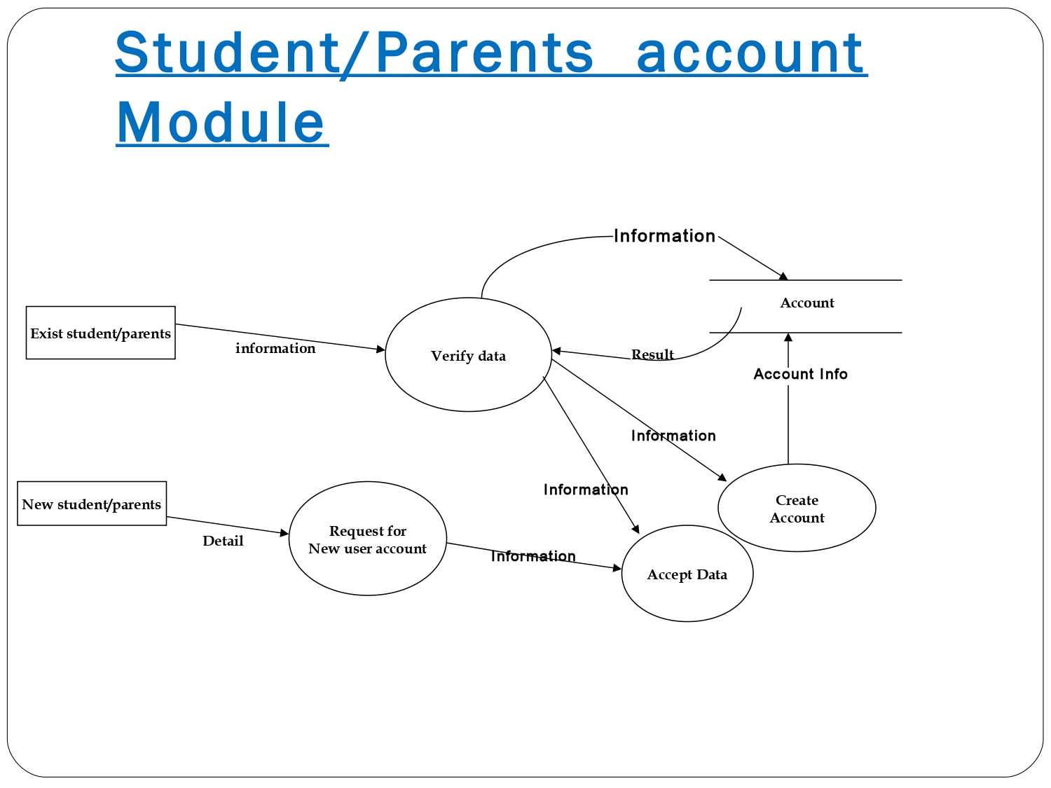

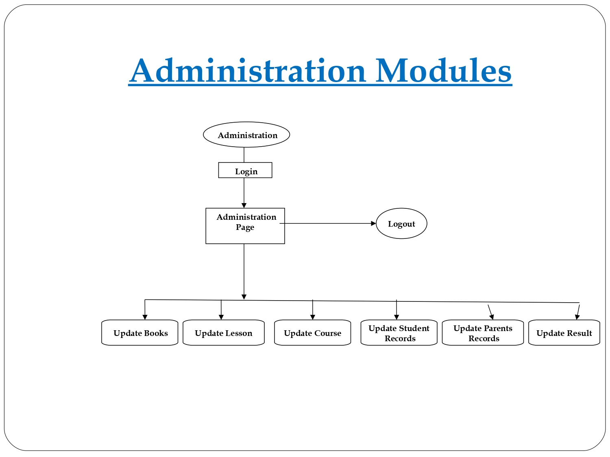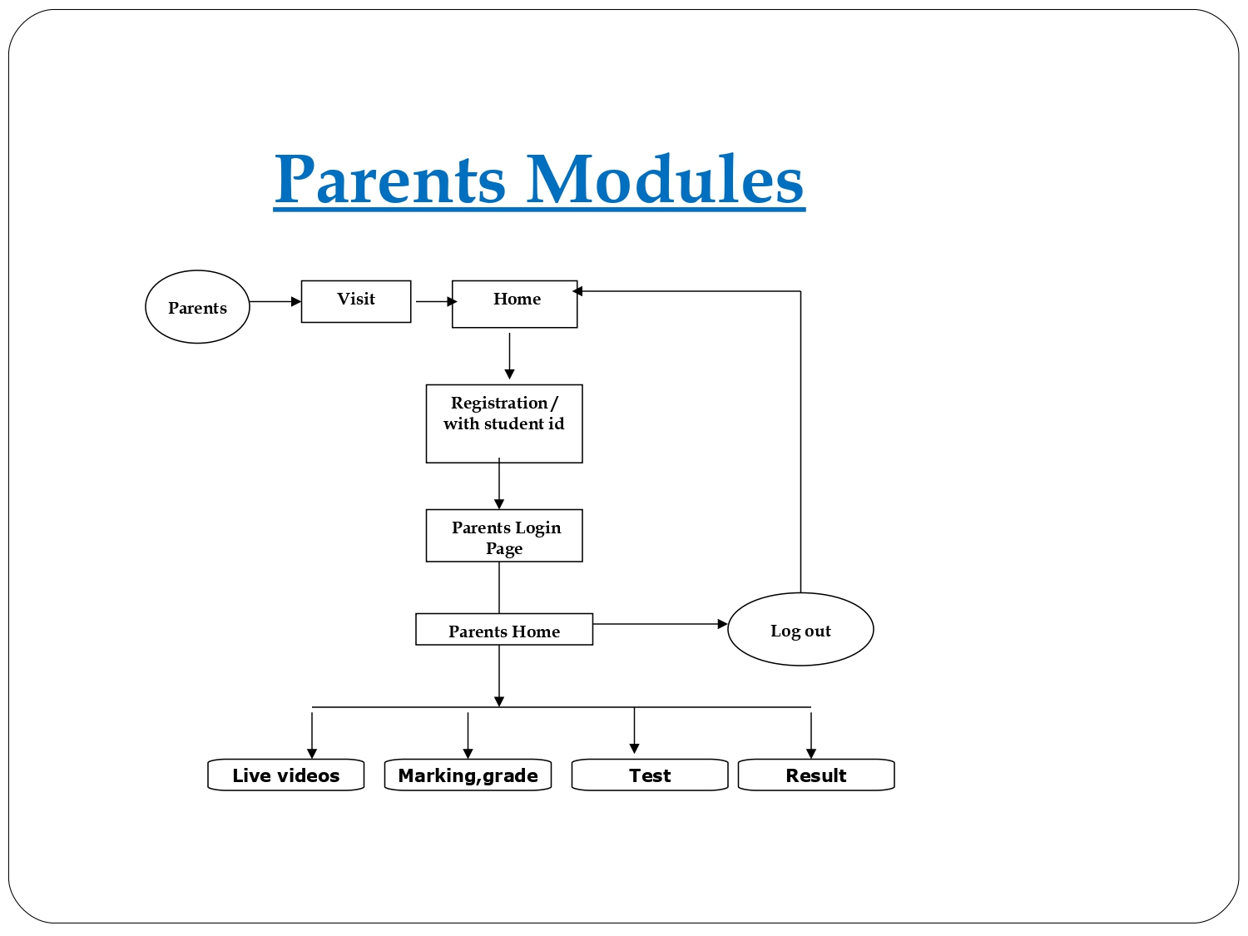

**: - SECOND LEVEL DFD**

**6. ER-DIAGRAM:**

E-R (Entity – Relationship) Model Diagram.

In software engineering an entity relationship model diagram (E-R model diagram) is a data model for describing a database in an abstract way. An ER diagram shows the relationship among entity sets. An entity set is a group of similar entities and these entities can have attributes. In terms of DBMS, an entity is a table or attribute of a table in database, so by showing relationship among tables and their attributes, ER diagram shows the complete logical structure of a database. It is widely used to develop an initial design of a database. It describes data as a collection of entities, relationship and attributes.

E-R Diagram are composed of:

**a) ENTITY:**

An entity is an object or component of data. An entity is represented as rectangle in an ER diagram.

**ENTITY**

Entity

**b) ATTRIBUTE:**

An attribute describes the property of an entity. An attribute is represented as Oval in an ER diagram. There are four types of attributes:

➢ Key attribute

➢ Composite attribute

➢ Multivalued attribute

➢ Derived attribute

**ATTRIBUTE**

Attribute

**c) RELATIONSHIP:**

A relationship is represented by diamond shape in ER diagram, it shows the relationship among entities. There are four types of relationships:

➢ One to One

➢ One to Many

IS-A /

HAS-A

➢ Many to One

➢ Many to Many

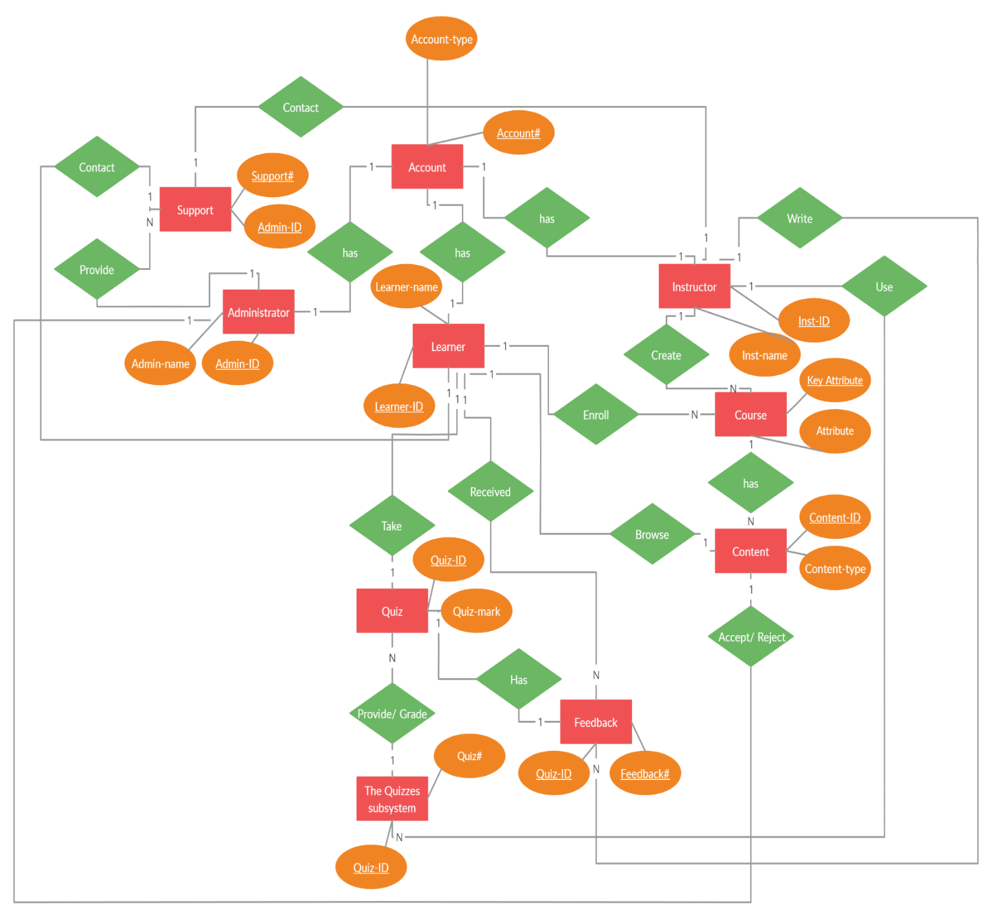

**7. DATA DICTIONARY:**

A Data Dictionary is a collection of names, definitions, and attributes about data elements that are being used or captured in a database, information system, or part of a research project. It describes the meanings and purposes of data elements within the context of a project, and provides guidance on interpretation, accepted meanings and representation. A Data Dictionary also provides metadata about data elements. The metadata included in a Data Dictionary can assist in defining the scope and characteristics of data elements, as well the rules for their usage and application.

Data Dictionaries are useful for a number of reasons. In short, they:

* Assist in avoiding data inconsistencies across a project.
* Help define conventions that are to be used across a project.
* Provide consistency in the collection and use of data across multiple members of a research team.
* Make data easier to analyse.
* Enforce the use of Data Standards.